DAY 4: USER EXPERIENCE & NAVIGATION IMPROVEMENTS

Focus: Enhanced User Interface and Navigation Flow

Issues from Previous Day:
- Poor user experience in add, control and view device operations
- Users getting stuck in menus without return options
- No graceful handling of Ctrl+C interruptions
- Basic list view lacking proper formatting
- Menu navigation confusing and not intuitive

Development Activities
Navigation Enhancement:
OLD CODE: No return to menu options
private static void addDevice() {
// User gets stuck in this menu
System.out.println("Add Device Menu");
// No way to return to main menu
}

NEW CODE: Enhanced navigation with return options
private static void addDevice() {
while (true) {
System.out.println("\n=== Add Device Menu ===");
System.out.println("[Navigation] Enter '0' at any prompt to return to Main Menu");
System.out.println("Enter 'back' to return to previous menu");

String input = getValidatedInputWithNavigation("Device Type");
if (input == null || "0".equals(input)) {
return; // Return to main menu
}
if ("back".equals(input.toLowerCase())) {
return; // Return to previous menu
}
// Process device addition
}
}

// Ctrl+C handling enhancement
private static void setupGracefulShutdown() {
Runtime.getRuntime().addShutdownHook(new Thread(() > {
System.out.println("\n[SYSTEM] Ctrl+C detected!");
System.out.println("Enter '0' and press Enter to return to Main Menu");
System.out.println("Or press Ctrl+C again to exit application");
}));
}

Enhanced Device List View:
OLD CODE: Basic list output
public void viewDevices() {
for (Gadget gadget : gadgets) {
System.out.println(gadget.getType() + " " + gadget.getStatus());
}
}

NEW CODE: Formatted table view
public void viewDevicesInTable() {
System.out.println("\n" + "=".repeat(80));
System.out.println(" YOUR SMART DEVICES");
System.out.println("=".repeat(80));
System.out.printf("%15s %20s %15s %10s %15s%n",
"DEVICE TYPE", "MODEL", "ROOM", "STATUS", "LAST UPDATED");
System.out.println("".repeat(80));

for (Gadget gadget : gadgets) {
System.out.printf("%15s %20s %15s %10s %15s%n",
gadget.getType(),
gadget.getModel(),
gadget.getRoomName(),
gadget.getStatus(),
gadget.getLastModified().format(DateTimeFormatter.ofPattern("MMM dd, HH:mm"))
);
}
System.out.println("=".repeat(80));
}

Bug Fixes Implemented:
1. Menu Navigation Issues Fixed
Added return to main menu option (Enter '0')
Added return to previous menu option (Enter 'back')
Proper menu flow and navigation breadcrumbs

2. Ctrl+C Handling Fixed
Graceful shutdown hook implementation
User friendly exit process
Prevention of abrupt application termination

3. User Experience Improvements
Clear navigation instructions on every screen
Consistent input validation across all menus
Error message improvements with helpful suggestions

Testing of user experience improvements:
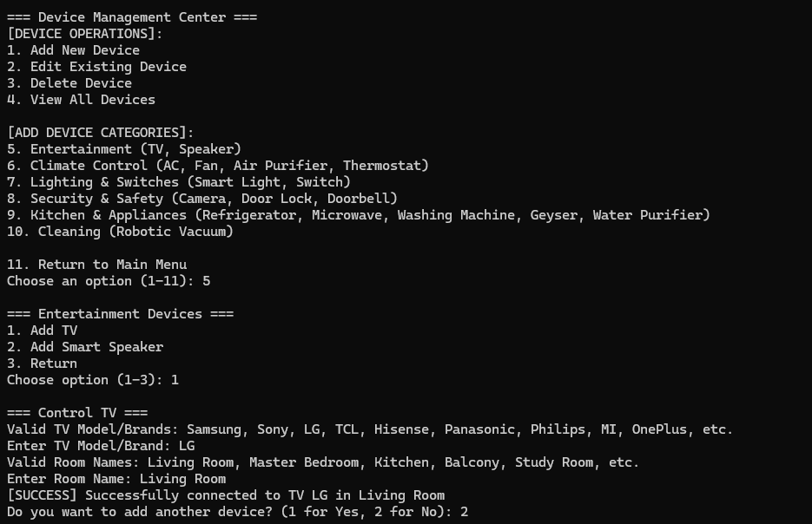

View Gadgets:
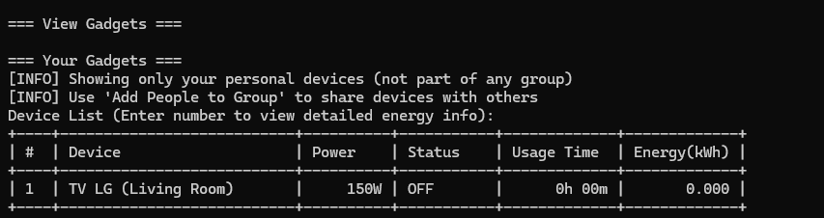

Device Control:
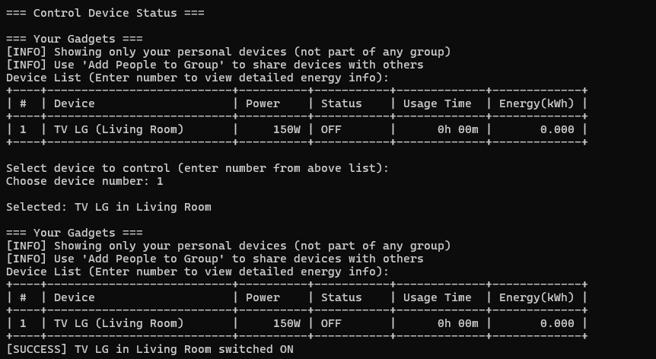

Conclusion Day 4:
Significantly improved user experience with enhanced navigation, proper menu flows, and graceful interruption handling. Users can now easily navigate between menus and return to main menu from any location.

Key Achievements:
- Enhanced navigation system with return options
- Improved device list formatting with table view
- Graceful Ctrl+C handling implementation
- Better user guidance and error messages

Network Architecture Overview
System Architecture
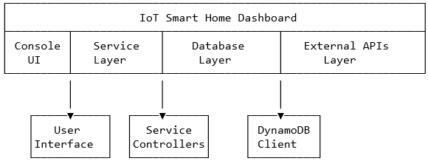

Networking Components
1. Database Networking Layer
DynamoDBConfig.java (`com.smarthome.util.DynamoDBConfig`)
Purpose: Centralized database connectivity management with dual-mode support (Local/Cloud)

Key Networking Features:
- HTTP Endpoint Configuration: Configurable endpoints for local development and AWS cloud
- Connection Management: Persistent connection handling with proper resource cleanup
- Dual Environment Support: Seamless switching between local DynamoDB and AWS DynamoDB

Network Configuration:
// Local Development Environment
dynamodb.local.endpoint=http://localhost:8002
dynamodb.region=us-east-1

// AWS Cloud Environment
dynamodb.region=us-east-1

Connection Implementation:
// Local DynamoDB Connection (Development)
DynamoDbClient.builder()
.endpointOverride(URI.create("http://localhost:8002"))
.region(Region.of("us-east-1"))
.credentialsProvider(StaticCredentialsProvider.create(localCredentials))
.build();

// AWS DynamoDB Connection (Production)
DynamoDbClient.builder()
.region(Region.of("us-east-1"))
.credentialsProvider(DefaultCredentialsProvider.create())
.build();

Networking Features:
- Connection Testing: Real-time connectivity validation via `listTables()` API calls
- Fallback Mechanism: Graceful degradation to demo mode when network unavailable
- Resource Management: Proper connection lifecycle management with cleanup on shutdown

2. Weather Service Integration
WeatherService.java (`com.smarthome.service.WeatherService`)
Purpose: Weather data collection and processing for smart automation decisions

Network Integration Approach:
- Manual Data Input: User-provided weather data through console interface
- Simulated Data Generation: Algorithmic weather simulation for demo purposes
- Future API Integration Ready: Architecture supports external weather API integration

Data Collection Methods:
1. Real-time User Input:
- Temperature, humidity, wind speed, air quality index
- Weather condition selection (Sunny, Rainy, Stormy, etc.)

2. Simulated Weather Generation:
- Algorithm-based weather pattern simulation
- Realistic data ranges and variations
- 5-day forecast generation

Automation Integration:
- Weather-based device control suggestions
- Energy optimization recommendations
- Safety-first automation during severe weather

3. Network Configuration Management
Application Properties (`application.properties`)

Network Configuration Parameters:
properties
Database Networking
dynamodb.local=true
dynamodb.local.endpoint=http://localhost:8002
dynamodb.region=us-east-1

Application Configuration
app.debug=true
app.name=IoT Smart Home Dashboard
app.version=1.0.0

4. Maven Dependencies - Network Stack
Network-Related Dependencies (`pom.xml`)

<!-- AWS SDK for DynamoDB -->
<dependency>
<groupId>software.amazon.awssdk</groupId>
<artifactId>dynamodb</artifactId>
<version>2.21.29</version>
</dependency>

<dependency>
<groupId>software.amazon.awssdk</groupId>
<artifactId>dynamodb-enhanced</artifactId>
<version>2.21.29</version>
</dependency>

Network Capabilities:
- HTTP/HTTPS Communication: AWS SDK provides secure HTTPS communication
- Authentication: Support for AWS credentials and local development authentication
- Connection Pooling: Built-in connection management and pooling
- Retry Logic: Automatic retry mechanisms for failed network requests

Network Communication Patterns
1. Database Communication Pattern

// Connection Establishment
initializeDynamoDBClient() → Network Connection → Endpoint Resolution

// Data Operations
Service Layer → DynamoDB Client → HTTP Request → AWS/Local DynamoDB → Response

// Connection Management
Application Shutdown → Resource Cleanup → Connection Termination

2. Service Layer Architecture
Service Communication Flow:

SmartHomeService ↔ CustomerService ↔ DynamoDBConfig ↔ Network Layer
↔ GadgetService ↔ Database Client ↔ DynamoDB Server
↔ WeatherService ↔ Data Processing

3. Error Handling and Resilience
Network Error Handling Strategy:
- Connection Failures: Graceful degradation to demo mode
- Timeout Management: Configurable timeout values for network operations
- Retry Logic: Built-in AWS SDK retry mechanisms
- Logging: Comprehensive error logging for network issues

Security Implementation
1. Authentication and Authorization
Database Security:
- Local Development: Dummy credentials for local DynamoDB
- AWS Production: AWS credential provider chain
- No Hardcoded Secrets: Environment-based credential management

Connection Security:
- HTTPS Enforcement: All AWS communications use HTTPS
- Regional Configuration: Region-specific endpoint configuration
- Credential Management: Secure credential handling through AWS SDK

2. Network Security Best Practices
- No Direct Database Exposure: All database access through service layer
- Configuration Externalization: Network settings in properties files
- Error Message Sanitization: No sensitive information in error logs

Performance Considerations
1. Connection Management
Optimization Strategies:
- Connection Reuse: Single client instance across application lifecycle
- Resource Pooling: AWS SDK manages connection pooling internally
- Lazy Initialization: Database connections established on demand

2. Network Efficiency
Data Transfer Optimization:
- Batch Operations: Efficient bulk data operations where applicable
- Minimal Data Transfer: Only essential data transmitted
- Connection Keep-alive: Persistent connections reduce overhead

Development and Deployment
1. Local Development Setup
Network Setup Requirements:

Start Local DynamoDB
java -Djava.library.path=./DynamoDBLocal_lib -jar DynamoDBLocal.jar -sharedDb -port 8002

Configure Application
dynamodb.local=true
dynamodb.local.endpoint=http://localhost:8002

2. Production Deployment
AWS Configuration:
properties
dynamodb.local=false
dynamodb.region=us-east-1
AWS credentials through environment or IAM roles

Future Networking Enhancements
1. Planned Network Integrations

External API Integrations:
- Weather APIs: OpenWeatherMap, AccuWeather integration
- IoT Device APIs: Direct device communication protocols
- Cloud Services: Additional AWS services integration

2. Protocol Enhancements
Potential Network Improvements:
- WebSocket Support: Real-time device status updates
- REST API Layer: HTTP API for external system integration
- MQTT Protocol: IoT device communication protocol

3. Security Enhancements
Network Implementation Summary
The IoT Smart Home Dashboard implements a robust networking architecture with the following key characteristics:

1. Flexible Database Connectivity: Dual-mode support for local development and cloud deployment
2. Resilient Error Handling: Graceful degradation and comprehensive error management
3. Security-First Approach: Secure credential management and encrypted communications
4. Scalable Design: Architecture supports future network service integrations
5. Developer-Friendly: Easy local development setup with comprehensive documentation

This networking implementation provides a solid foundation for IoT device management while maintaining flexibility for future enhancements and integrations.

